

**NAAN MUDHALVAN**

**MERN STACK POWERED BY MONGODB**

**PROJECT TITLE: BOOK STORE**

**TEAM MEMBERS:**

**TEJASREE M S – 2021506113**

**POORNIMA K – 2021506063**

**SREENITHI B - 2021506105**

**RITHIKA SAFFRON - 2021506072**

**Aim**:

The aim of the Book Store project is to design and develop an interactive and user-friendly web application using the MERN stack (MongoDB, Express.js, React.js, and Node.js). This project intends to provide users with an efficient platform to browse, search, and purchase books, while administrators can manage book inventory, user data, and order processing seamlessly.

**Roles And Responsibility:**

**User:**

* **Registration:** Users are responsible for registering an account on the BookEase book store app by providing essential details such as name, email, and password.
* **Profile Management:** Users have the capability to manage their profiles, allowing them to update information like email, name, and password.
* **Book Browsing:** Users can browse through the available books, explore different genres, and search for specific titles or authors.
* **Purchase:** Users can add books to their cart, specify quantities, and complete purchases securely.
* **Feedback:** Provide feedback and ratings for purchased books and sellers on the BookEase platform.
* **Logout:** Lastly, they can logout from the BookEase book store app.

**Seller:**

* **Registration:** Sellers register an account on the BookEase book store app by providing necessary details such as business name, email, and password.
* **Profile Management:** Sellers have the capability to manage their profiles, allowing them to update information like email, business name, and password.
* **Book Listing:** Sellers can add new books to the platform, including details such as title, author, genre, description, price, and quantity available.
* **Inventory Management:** Sellers can manage their book inventory, updating stock levels, removing inactive listings, and handling book ratings.
* **Order Fulfillment:** Sellers are responsible for fulfilling orders placed by users, including packaging and shipping books in a timely manner.
* **Logout:** Finally, they can logout from the BookEase book store app.

**Admin:**

* **System Management:** Admins have full control over all aspects of the book store system, overseeing functionalities, configurations, and security.
* **User Management:** Admins can manage user information, including creating, updating, and deleting accounts. They also have authority over user ratings.
* **Book Management:** Admins can manage book listings, including adding new books, updating details, and removing inactive listings from the platform.
* **Seller Management:** Admins have the authority to manage seller information, including approving new seller accounts, updating profiles, and handling seller ratings.
* **Logout:** Finally, they can logout from the BookEase book store app.

This adaptation aligns user, seller, and admin functionalities with those of a book store app, emphasizing actions and terminology relevant to book browsing, purchasing, and selling.

**Activity diagram:**

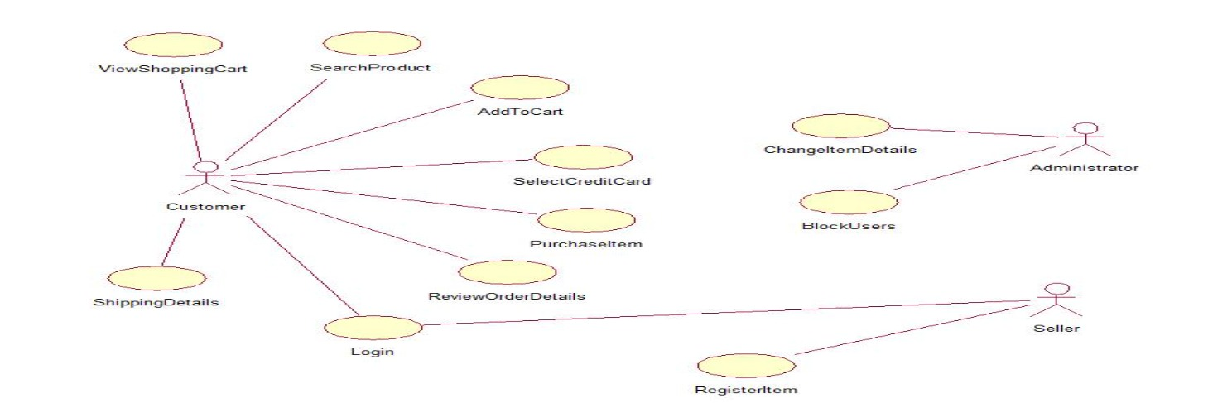

**Application Flow:**

**1. Required tools and software:**

* Node.js.
* MongoDB.
* Create-react-app.

**2. Create project folders and files:**

* Client folders.
* Server folders.

**3. Install Packages:**

* Frontend npm Packages
* Axios.
* React-Router –dom.
* Bootstrap.
* React-Bootstrap.
* Backend npm Packages
* Express.
* Mongoose.
* Cors.

**Implementation:**

**Login page**



**Product listing page with Sort and filter products**

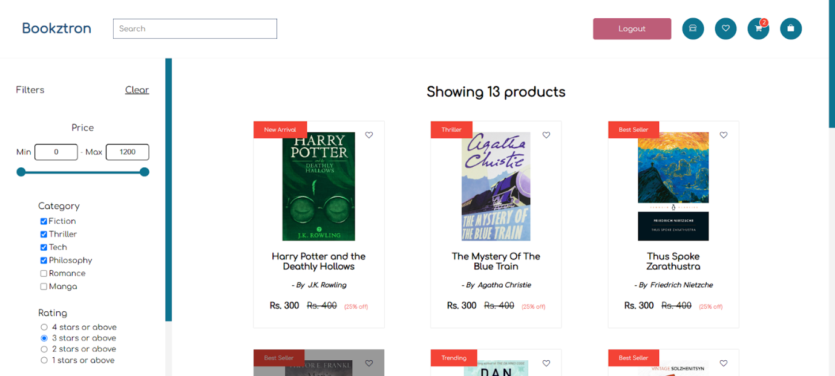



**Cart- remove and add quantities of the books in the cart**

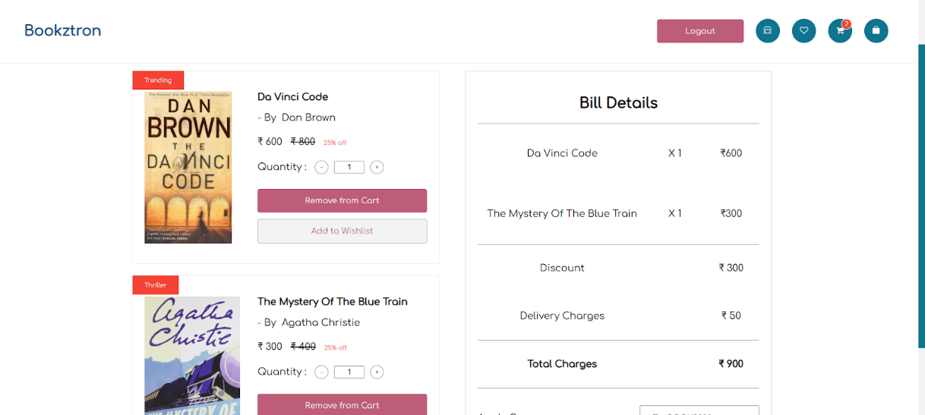

**Payment integration with Razorpay**

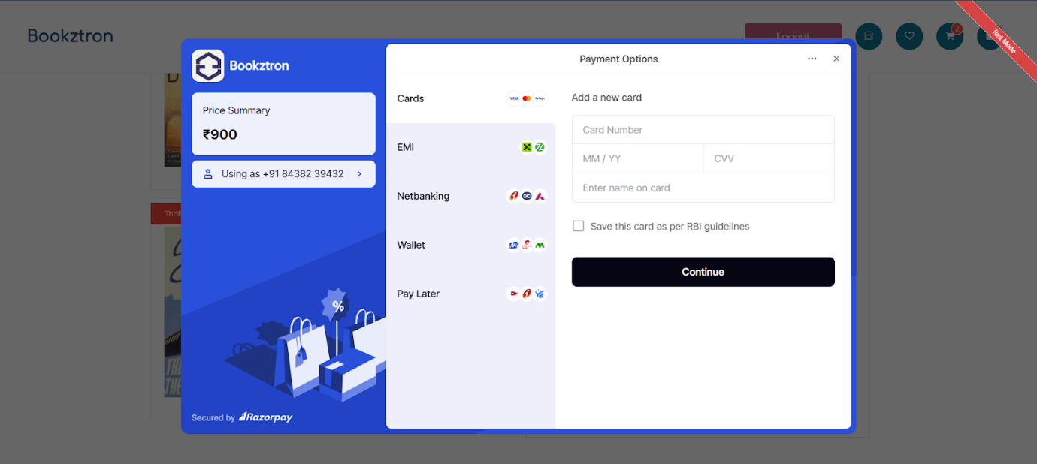

**Wishlist**

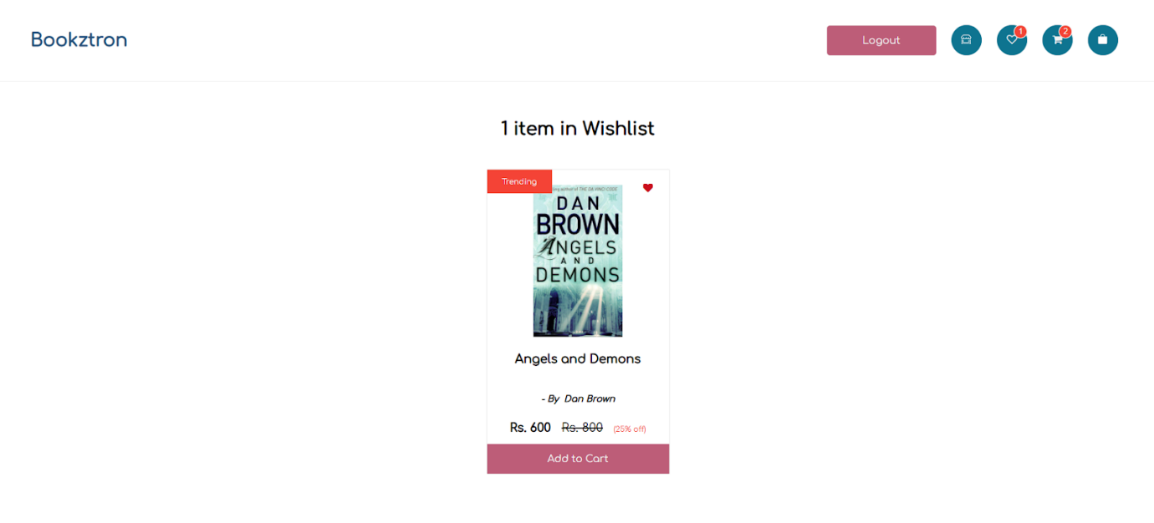

**Conclusion**:

The Book Store project successfully demonstrates the development of a full-stack web application that leverages the MERN stack to deliver a responsive and feature-rich online book retailing experience. The project highlights the integration of front-end and back-end technologies to create an engaging and interactive user interface, secure user authentication, and a robust backend for managing data efficiently. This project emphasizes the importance of modern web development practices and provides a comprehensive platform that could be scaled and enhanced with further features.